29.7: a) 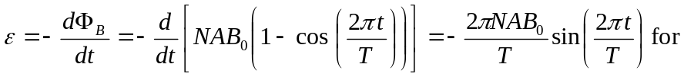
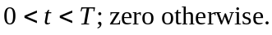
b) 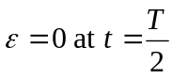
c) 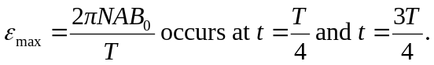
d) From 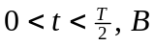 is getting larger and points in the direction. This gives a clockwise current looking down the axis. From 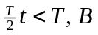 is getting smaller but still points in the direction. This gives a counterclockwise current.

